Modeling a Food Web
Part A
The Ecosystem that I chose for the project is that of Lake George. The lake is located in a protected area of South Eastern New York. It has many islands and is surrounded by mountains. On average, the temperature of the water of the lake is 54° F. The depth of the lake goes up to 60 m. However, the food webs of interest are in the surface waters that do not exceed 20 m. The lake has high salinity; about one-third of the average salinity of sea water. The lake has a neutral pH. The lake mainly receives water from tributaries and partly from groundwater.
Part B
Producers – algae, phytoplankton
Primary consumers - copepods, cladocerans, tadpoles
Secondary consumers - crayfish, minnows
Tertiary consumers – salmon, trout
Quaternary consumers – man, decomposers like fungi
Part C
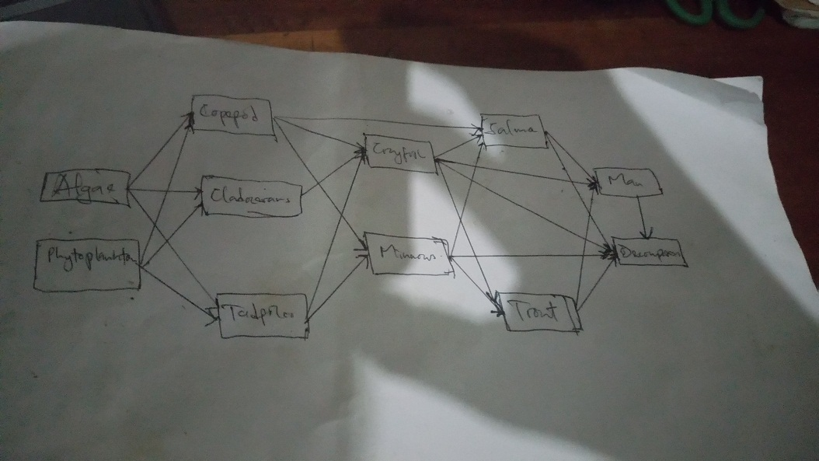
The introduction of an invasive species that would consume the primary producers would affect organisms at all levels of the energy pyramid. At the first trophic level, the population of primary producers would decrease considerably. At the second level, the primary consumers would have inadequate food because of increased competition. As part of their adaptation, these consumers may have to migrate or survive on different diets. With death or migration of primary consumers, the secondary consumers would also starve hence forcing them to migrate or find new diets like the new invasive species. The tertiary and quaternary consumers would also have less food in the long run hence forcing them to find new habitats with plenty of food.
Part D
One natural disaster that is greatly influencing the ecology of Lake George is global warming. The increasing world temperatures are gradually increasing the water in the lake and the temperature of the water in the lake. These conditions are decreasing the survival of some types of phytoplankton. Considering the fact that phytoplankton is a major producer in the lake’s ecology, the decrease in the population of phytoplankton is likely to decrease the amount of food available for most primary consumers hence decreasing their population. The decrease in phytoplankton also increases the competition for algae hence decreasing its population. Eventually, a decrease in food will decrease the populations of all members of the food web.
Part E
Human activities can adversely affect the ecosystem of Lake George too. For instance, the construction of industries that produce acidic effluents and various greenhouse gases that led to the creation of acid rain can negatively impact the ecosystem. Increased acidity of the lake water directly kills algae, phytoplankton, tadpoles, and minnows. This phenomenon will decrease the amount of food for primary and secondary consumers hence the survival of organisms at all levels of the chain.

